CTM-I Use Case

Range Delete

Version 0.1

Use Case Name | Range Delete
Actor | Market Ops, Operations, App Support
Pre-conditions /Assumptions | User has Browser and is aware of the http path to the application.  User has successfully logged into the CTM-I application.  User has the right role to see the menu options.
Post Conditions | None
Screenshot | 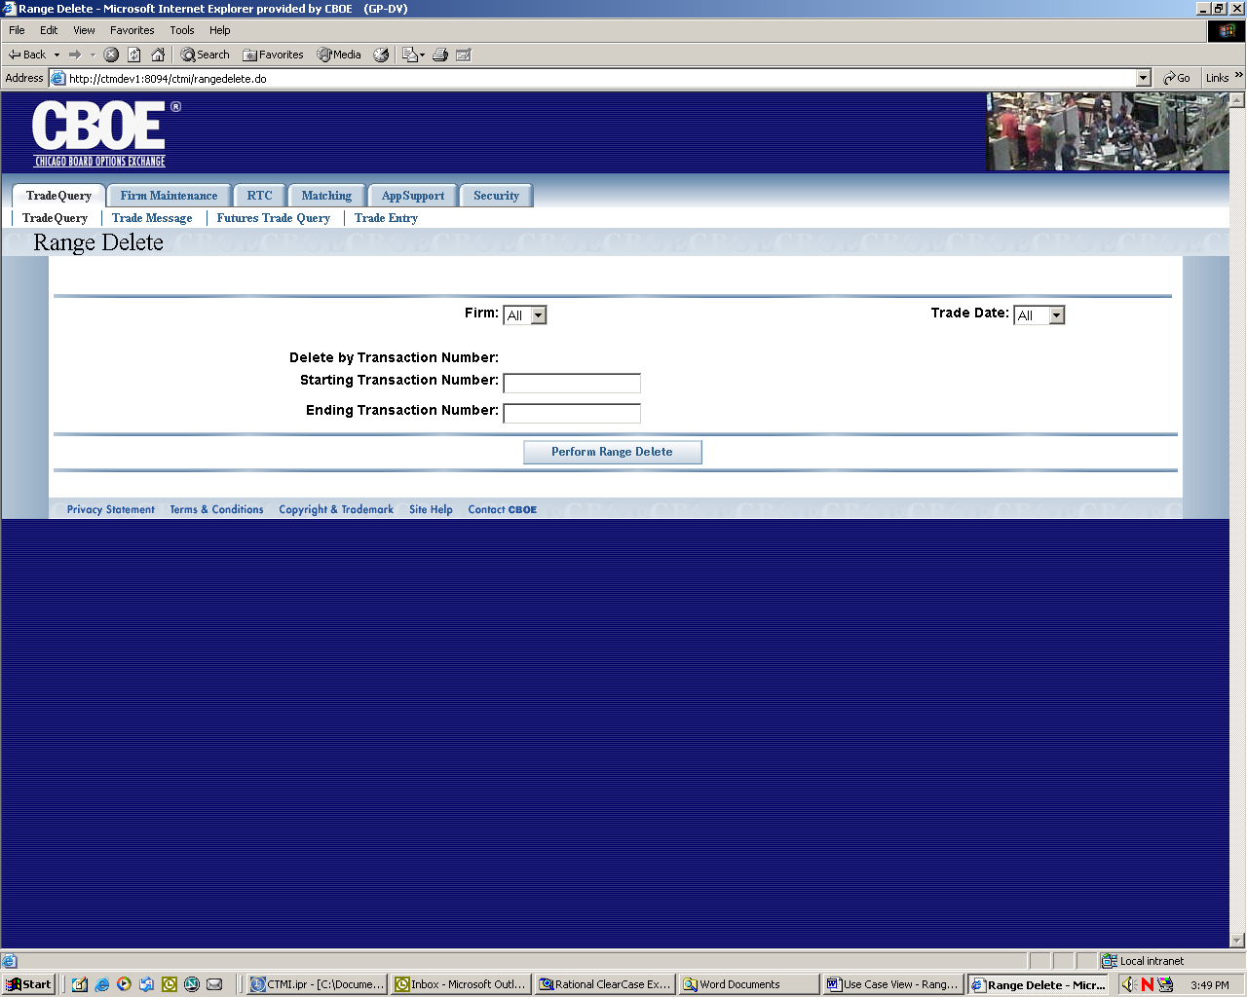
Flow of Events | - User selects “Range Delete” from the menu.  - Range Delete screen is displayed.  - The user is required to enter the start transaction number and end transaction number for the range delete. The range is inclusive.  - Use selects “All” or “AsOf” to select today’s trades and yesterday’s trades or just asofs.  - The user presses the “Perform Range Delete” button to begin the processing  - The request is sent to CTM-R to process  - Range Delete screen is displayed with the results from CTM-R.
Alternative Path | None

